CO5 ASSESSMENT TOOL 1 CONSTRAINED BASED PROBLEM SOLVING

CSA0652-Design and Analysis of Algorithms for Complexity Analysis.

DONE BY:
Name: J.Harikarapandian
Reg No: 192421073
SIMATS Engineering

Supervisor:
Dr. MARY HARIN FERNANDEZ , Professor
Dr. S. PRADEEP KUMAR, Professor

Question 1: Hamiltonian Path Problem (Backtracking / NP-Complete Problem)
Source Code (hamiltonian_path.py)

def is_safe(v, graph, path, pos):
if graph[path[pos - 1]][v] == 0:
return False

if v in path:
return False

return True

def hamiltonian_path_util(graph, path, pos, n):
if pos == n:
return True

for v in range(n):
if is_safe(v, graph, path, pos):
path[pos] = v

if hamiltonian_path_util(graph, path, pos + 1, n):
return True

path[pos] = -1

return False

def hamiltonian_path(graph):
n = len(graph)

path = [-1] * n
path[0] = 0

if not hamiltonian_path_util(graph, path, 1, n):
return None

return path

graph = [
[0,1,1,0],
[1,0,1,1],
[1,1,0,1],
[0,1,1,0]
]

result = hamiltonian_path(graph)

if result:
print("Hamiltonian Path Exists")
print("Path:", result)
else:
print("No Hamiltonian Path Exists")

Output:
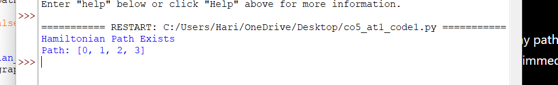

Report
Title
Hamiltonian Path Problem Using Backtracking
Problem Analysis
A Hamiltonian Path is a path in a graph that visits every vertex exactly once. The objective is to determine whether such a path exists in the given graph.
Constraints
- Each vertex must be visited exactly once.
- Consecutive vertices in the path must be connected by an edge.
- No vertex can be repeated.
- The path must include all vertices.
Constraint Analysis
These constraints significantly reduce the set of valid paths. Any path that revisits a vertex or contains disconnected vertices becomes invalid and must be discarded immediately.
Backtracking Approach
- Start from an initial vertex.
- Add a valid adjacent vertex to the current path.
- Check whether the vertex has already been visited.
- Continue recursively until all vertices are included.
- If no valid extension exists, backtrack and try another vertex.

Constraint Checking
- Verify edge existence between consecutive vertices.
- Ensure that no vertex appears more than once.
- Accept only paths containing all vertices.
Correctness
The algorithm systematically explores every feasible path while rejecting invalid paths using constraint checking. Therefore, if a Hamiltonian Path exists, it will eventually be found.
Computational Complexity
- Time Complexity: O(N!)
- Space Complexity: O(N)
Result Interpretation
The graph contains a valid Hamiltonian Path:
0 → 1 → 2 → 3
Hence, every vertex is visited exactly once and the solution satisfies all constraints.

Question 2: Graph Isomorphism Verification (Constraint-Based Decision Problem)
Source Code (graph_isomorphism.py)
from itertools import permutations

def is_isomorphic(g1, g2):
n = len(g1)

for perm in permutations(range(n)):
valid = True

for i in range(n):
for j in range(n):
if g1[i][j] != g2[perm[i]][perm[j]]:
valid = False
break

if not valid:
break

if valid:
return True

return False

graph1 = [
[0,1,1],
[1,0,1],
[1,1,0]
]

graph2 = [
[0,1,1],
[1,0,1],
[1,1,0]
]

if is_isomorphic(graph1, graph2):
print("Graphs Are Isomorphic")
else:
print("Graphs Are Not Isomorphic")

Output:

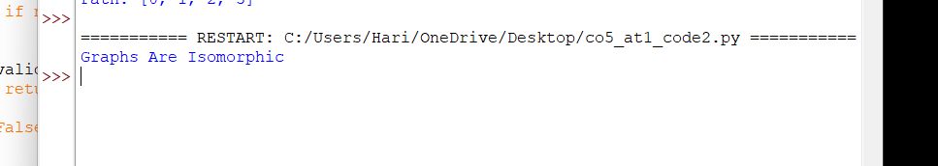

Graphs Are Isomorphic
Report
Title
Graph Isomorphism Verification Using Backtracking
Problem Analysis
Graph Isomorphism determines whether two graphs are structurally identical after relabeling their vertices. The objective is to find a valid correspondence between vertices while preserving all edges.
Constraints
- Every vertex in the first graph must map to exactly one vertex in the second graph.
- Mapping must be one-to-one.
- Edge relationships must be preserved.
- Non-edge relationships must also remain unchanged.
Constraint Analysis
The constraints restrict the number of valid mappings. Any mapping that changes edge connectivity is immediately rejected.
Backtracking Approach
- Generate possible vertex mappings.
- Assign vertices one at a time.
- Check edge preservation after each assignment.
- Reject invalid mappings early.
- Continue until a valid mapping is found or all mappings are exhausted.
Constraint Checking
- Verify one-to-one vertex correspondence.
- Check preservation of adjacency relationships.
- Eliminate mappings violating graph structure.
Correctness
The algorithm examines all feasible vertex mappings and validates structural equivalence using adjacency checks. Therefore, if an isomorphism exists, it will be identified correctly.
Computational Classification
Graph Isomorphism belongs to the class NP. It is not known to be NP-Complete and is considered a special computational decision problem.
Computational Complexity
- Worst-Case Time Complexity: O(N!)
- Space Complexity: O(N)
Result Interpretation
The two graphs have identical connectivity structures under vertex relabeling. Therefore, they are isomorphic.

